**Experiment1.3**

**Student Name: Nabha Varshney UID: 20BCS4995**

**Branch: CSE Section/Group: 20BCS_DM_704/A**

**Semester: 6th Date of Performance: 27/02/2023**

**Subject Name: MAD LAB Subject Code: 20CSP-356**

**Aim:** Create Application by Using Widgets.

**Objective:** Create Application by Using Widgets

**Widgets** are the micro-version of the application that consists of some functionality of the application that is displayed only on the **Home Screens** or the **Lock Screen**. For example, we

see **Weather**, **Time**, **Google Search Bars** on the Home Screen, and **FaceLock**, **FingerprintLock** on the Lock Screen, which are some of the Widgets available on the device. Widgets come along with the Application when you install it or download it from the Web. Generally, phones come with a manufacturing configuration but such elements can be adjusted by a user later in time.

**Script and Output:**

**Step 1: Create a New Project**

To create a new project in Android Studio please refer to [How to Create/Start a New Project in Android](https://www.geeksforgeeks.org/android-how-to-create-start-a-new-project-in-android-studio/) [Studio](https://www.geeksforgeeks.org/android-how-to-create-start-a-new-project-in-android-studio/). We are implementing it for both Java and Kotlin languages.

### **Step 2: Add the App Widget to the Project**

Right-Click on the app, move the cursor to new, find the “Widget” option at the end, select it.

Specify the required properties for the widget such as **min. width** and **height**, config file and preferred language, etc, and proceed. Files are automatically generated.

### **Step 3: Install and Run the Code**

* Install and Run the code on Android Virtual Device (AVD) or a personal device.
* Open the widget section of the phone, lookup for a widget with the Application name, select it, bring it to the home screen.

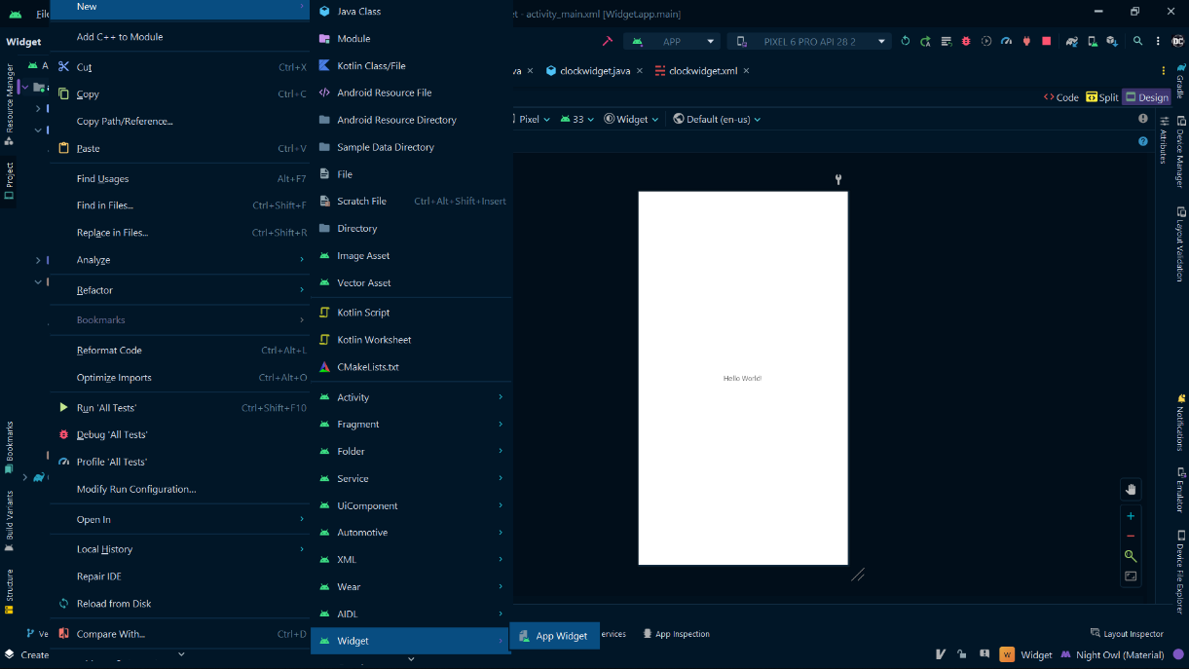During this selecting and deploying process, a few extra files are generated and minor changes are made to existing files as well. No programming is required for generating a basic widget and is only required if an application is to be embedded inside the widget, as discussed in the later parts of the article. Let us now explain the newly generated files the changes make to the existing ones, one by one.

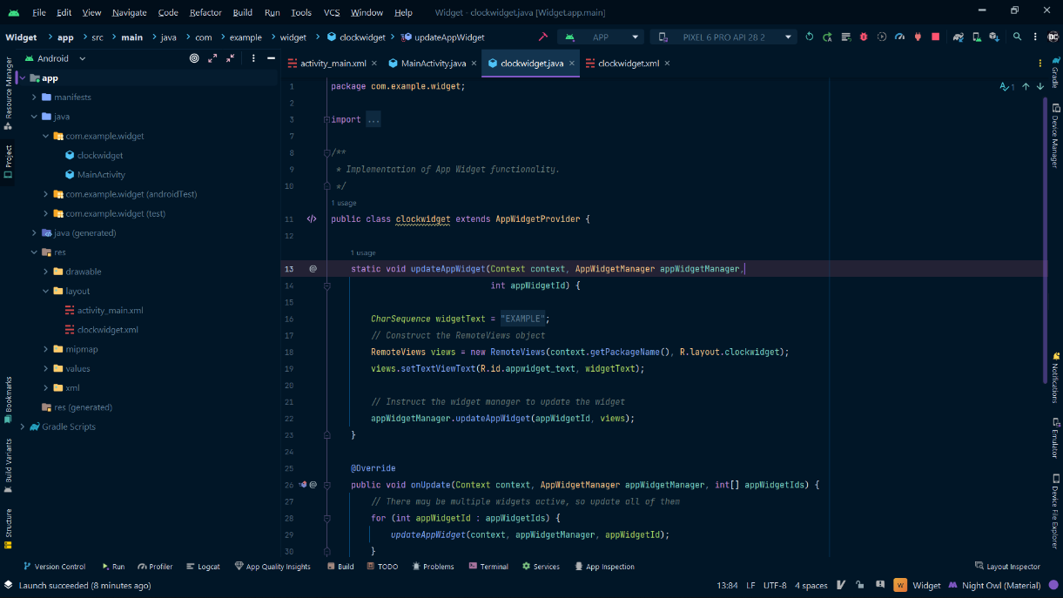ClockWidget.java

The Layout File

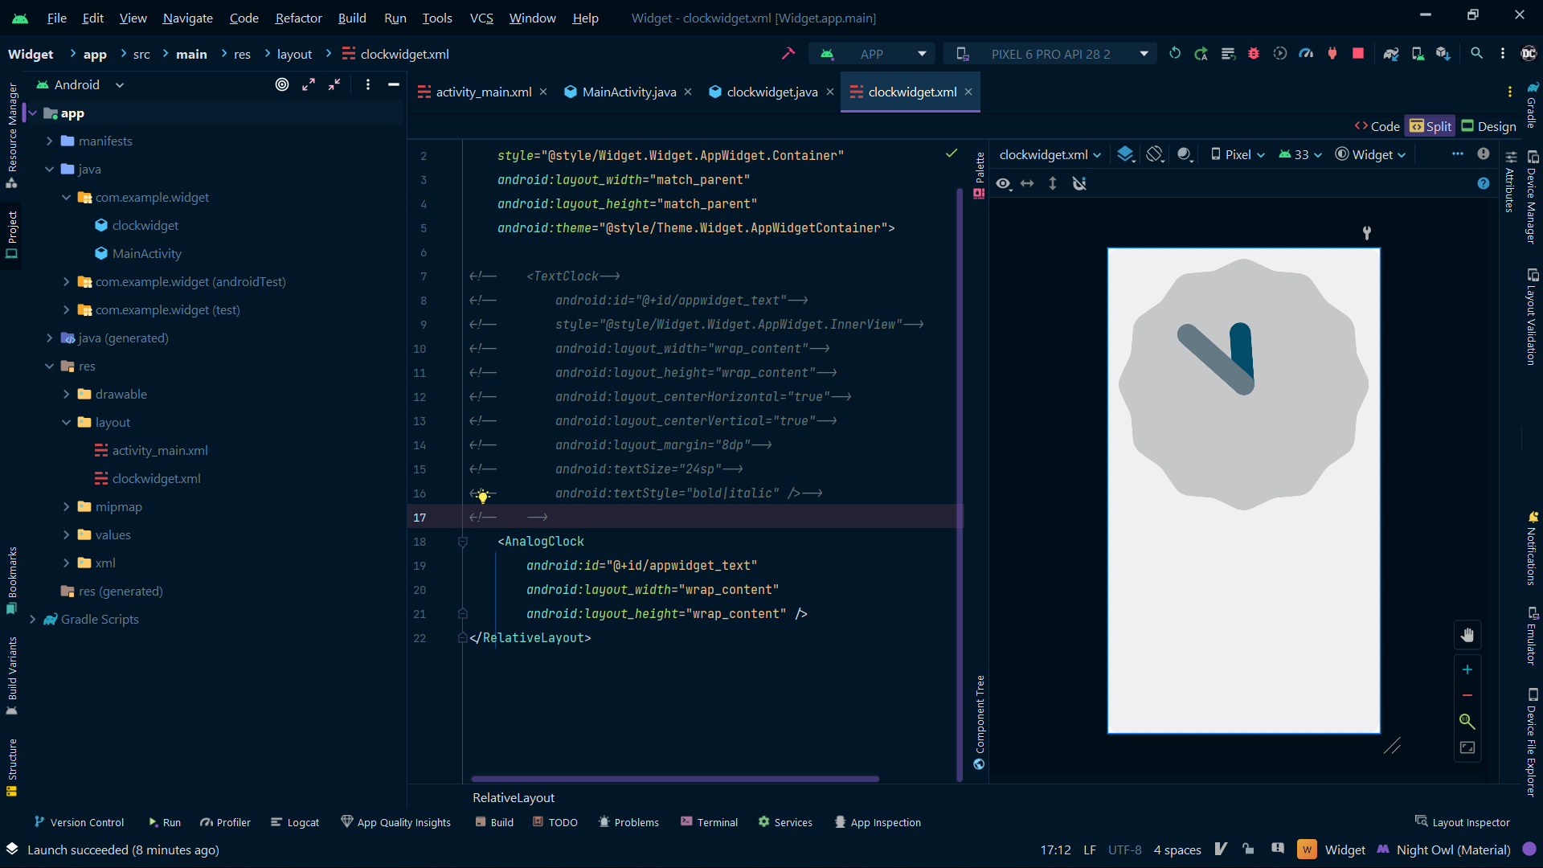

**Widget on the Home screen**

